**How to copy the audits from Mainline to Maintenance**

**Step 1:** Go to Fortify server🡪<https://fortify1.wdf.sap.corp/ssc/flex/index.jsp>

**Step 2:** select your project from which you want to copy the audits and click on Add button [highlighted with **yellow** color].

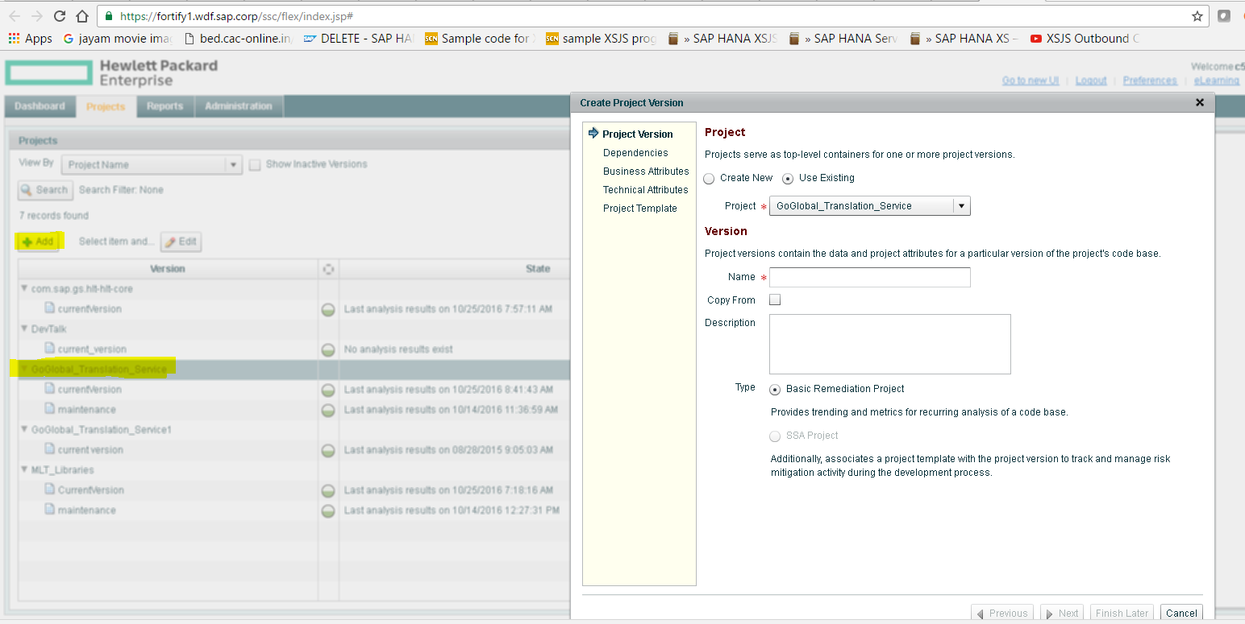

**Step 3:** Enter the version name and select **CopyFrom** option. When we select **CopyFrom** option, dropdown list will appear on the screen. Select which version of audits that you want to copy. Make sure that all the 6 settings must be selected [highlighted in rectangle box] then click on next.

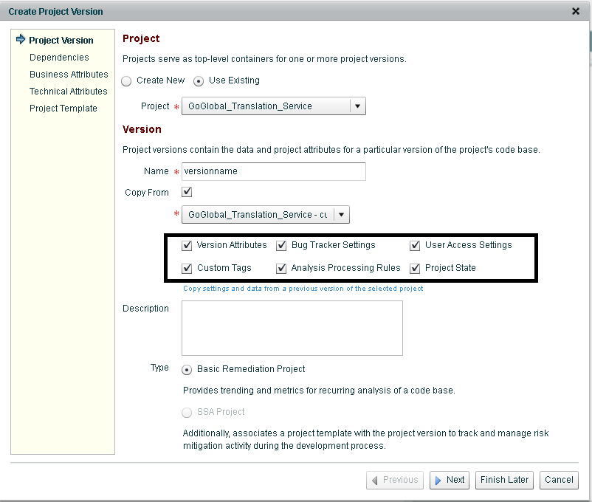

**Note**: If you just want to create a new version in that case don’t select **CopyFrom** option.

**Step 4:** In dependencies tab no need to fill anything. Click on next

**Step 5:** Enter the **PPMS** entry in business tab, click on next.

**Step 6:** No changes in Technical Attribute tab. Click on next

**Step 7.**Select the project template. Click on finish.

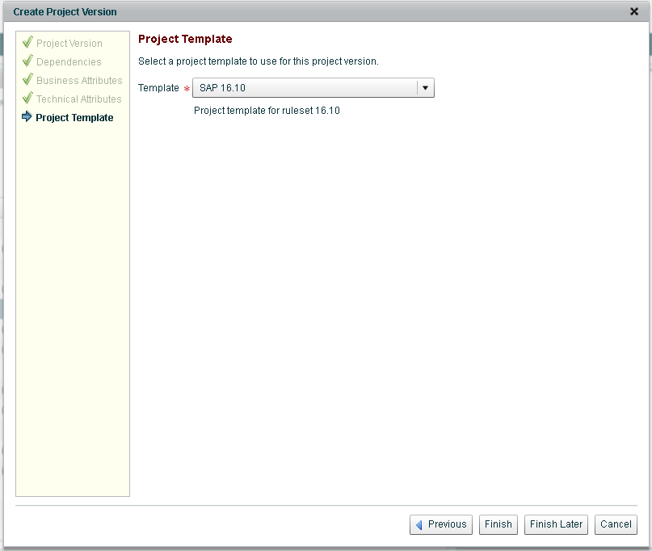

It will take some time to copy the audits, then we can see the changes in the new version.

**Note**: The above mentioned steps are applicable only, in order to copy the old audited issues. We may find new issues in the mainline when we trigger the mainline Jenkins job after the new code check in. In that case the total number of issues in mainline and maintenance may differ. We can make the total number of issues same by triggering the maintenance job but we have to audit the issues in both **currentversion** and **maintenance**.

Please find the below snapshots to understand the difference.

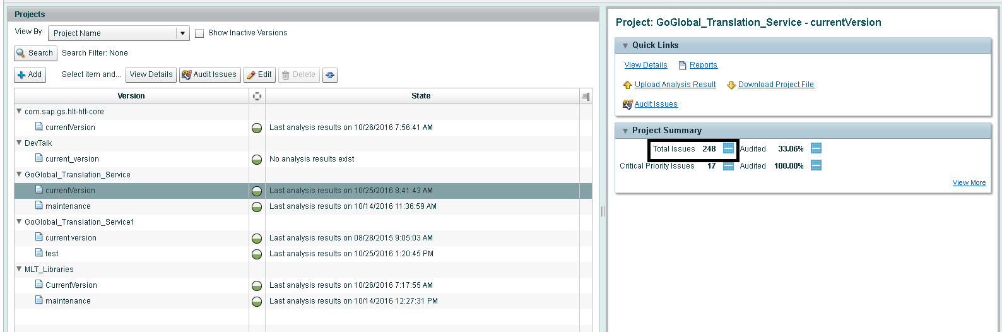

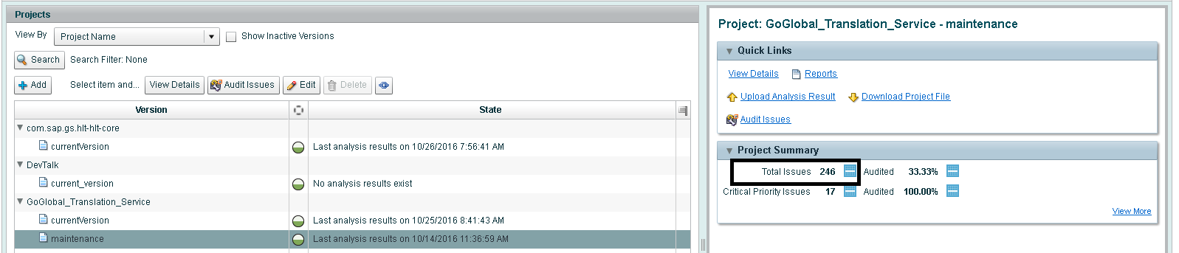

* When I copied the audits, the total number of issues and audited issues were same in both **currentversion** and **maintenance** version of GoGlobal_Translation_Service project.
* Because of code check in, new issues are reported to **currentversion** and **maintenance** version
* Once the new issues are reported, we need to audit both in currentversion and maintenance version. If we audit the new issues in **currentversion**, that will not be updated in **maintenance** version. In order to avoid this problem , please follow the below mentioned steps

1. After auditing the new issues in mainline, go to GoGlobal_Translation_Service project and select **CurrentVersion**. In the right corner you can see **Download Project File**,click on it**,** then you will get **result.fpr** file.

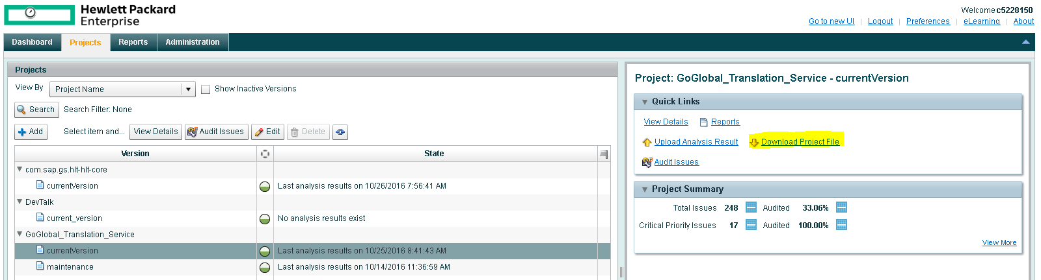

1. Now select the **maintenance** version**,** In the right corner you can see **upload Analysis File,** click on it and upload the **result.fpr** file which you downloaded from the current version.

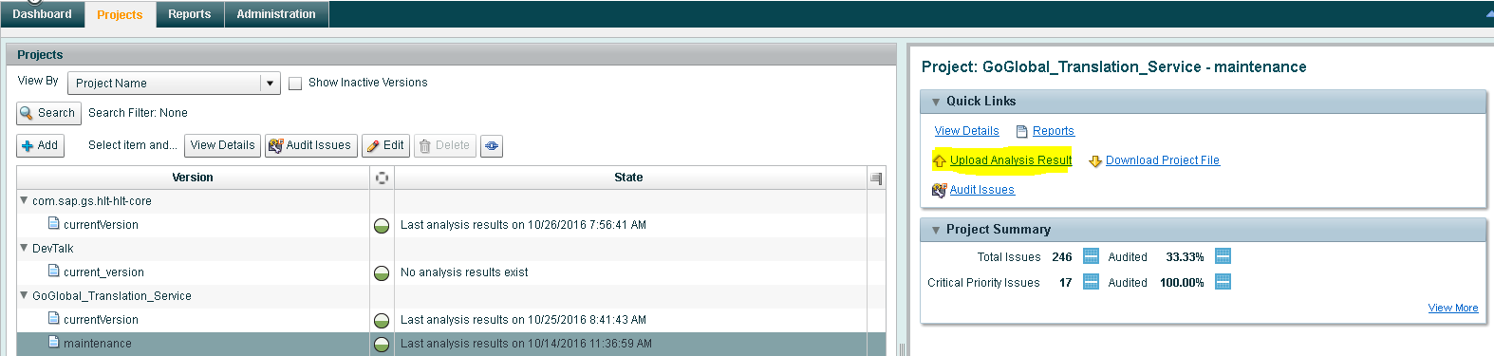

1. Double click on **maintenance**, select artifact .check the status .Once the process is completed then both the versions will contain the same number of audited issues.

